Test Summary Report

for

Worklist Orders Portal

# Overview:

The Testing will be conducted against the Worklist Orders Portal Web application to verify any immediate defects in UI, API and Data Design, function and end to end scenarios based on Business outcomes detailed in the BDD features in the Test Sections below (Not this is subset of the full feature scenarios as this not a full list of test cases due to this being a Candidate evaluation test).

## Manual Testing Scope:

Testing will be broken down into the following test phases and will be timeboxed to an hour based on this being a Candidate evaluation test:

* Data Design Testing
  + Note: Although we would expect Unit Testing to validate Field types, sizes, special characters and Data sizes we have conducted some of this in the scope of Exploratory Testing
* Exploratory Testing
* BDD Test Scenarios – Focusing on Business Scenarios for Order Worklist and New Order Creation
* Defects and Reporting
  + Focused on Reporting high priority defects (Note: Low priority defects may be ignored for this timeboxed purpose)
  + Screen Capturing defects on error conditions only – attached in Defect Screenshot section of this document below
  + Note: All Defects should capture recreation steps and the API payloads and field values into Jira when logging defects

## Automation Testing and Framework Scope:

Due to the timeframe and this being a Candidate evaluation test – I will limit the Automation framework to 1 or 2 Scenario examples that prove BDD/Cucumber using Specflow, and Page Object Modelling (POM). Note: This excludes DevOps Pipeline enablement and is focused on manually triggering the Automation execution on a local test environment due to timeframes.

* Automation Readiness review
  + To identify UI Design enhancements or process improvements for developers to enable faster Automation development and delivery.
  + Eg. BDD Automation Candidates map fields that are enabled with XPATH ID’s for faster Automation development
* Automation Test Scenarios Candidates are listed in the Automation Test Scenarios section
* Automation Framework and folder structure to implement BDD with the following folders:
  + Readme.MD file located in root folder will be updated to include all information to execute BDD Test Scenarios
  + Automation developed in C# using Specflow to integrate BDD with Selenium Webdriver
  + Dependency NU will be enabled in the Project to load locally.
  + /Features folder
    - Feature Scenarios using Cucumber Scenarios to verify Business Functions
    - Feature File names based on Key Features and pages of the application.
    - eg. Home, Orders, Orders - New Orders are deemed separate features or sub-features of the product.
    - API based Tests will be labelled with @API to initiate the API helper for Rest Requests
  + /Steps folder
    - Feature file naming conventions contain all steps for that feature area of the product.
    - Links the Feature files to Page files elements and Methods.
  + /Pages folder
    - Hold the Page Object Modelling of each Feature Page
    - Eg HomePage, OrdersPage, NewOrderPage
    - Feature Page files hold Elements and Methods that can be actioned on those pages.
  + /Core and /Hooks pages
    - Enable Webdrivers to the BDD Scenarios
    - Allow Before/After TestRun, Feature, Scenario triggers to start and terminate WebDriver utilities ready for testing.
    - Enable API based functionality.
  + /APISupport
    - Using RestSharp to delivery API Payloads and Response verifications

## Performance and Security Testing Out of Scope

As this is a limited time Candidate evaluation process – we would not be including Performance or Security Testing, but it would be noted that there is no Authentication method or Login framework and it would be highly recommended that this be designed into the framework.

## Test Case Management - BDD

Test Cases will be tracked in Jira or Test Case Management tool that supports BDD and direct integration into Automation Framework and DevOps Pipelines (TODO).

Test Cases will built in BDD with Cucumber/Gherkin Scenarios and grouped into Feature/Component and subfeature grouping to assist in tracking Feature coverage.

Eg. Test relating to Orders will be prefixed with the Component name “Orders” and follow a Page Object Modelling (POM) to track Automation Coverage using Feature naming conventions:

* Home Feature
* Orders Worklist Feature
* Orders – New Orders Feature

Test Cases will have Jira fields that can filter on:

* Automation Status
* Feature/Component Name

## Test Results

Both Manual and Automated Results should be tracked in the Test Case Management tool using feedback loop from DevOps Pipeline tool like Jenkins – uploading results directly into Jira (eg. Jira Xray).

For this Candidate evaluation process we will attach Defects in the Test Results Section tables below.

## Defect Management

Defects will be generated in this Word document for this Candidate evaluation process but should be tracked in Jira or related Test Management tool.

Defects should have fields that provides the Feature/component name as prefix to establish failures against those feature areas.

Defects should contain:

* Feature Component in the titles
* Link to failing Test Case BDD Scenario and failed Step
* Recreation Steps and API Payload/Test Data
* Screen Captures and Logs
* Severity based on Business/Customer Impact (as outlined in Quality Assurance Controls)

# Test Cases – Feature Scenarios

These features would normally be documented in Jira or Test Case Management tool supporting BDD but I have listed these based on the features and Scenarios tested.

Note Automation Status will be setup in Jira to Track what is being Automated and what has already been done:

Automation Status field:

* Not Required
* Automation Candidate
* Development In Progress
* Automated

## Home Feature Scenarios

Feature: Medical Worklist application - Home Features

*As an Administrator of Medical worklist Orders application for Clients*

*I would like to launch the Application Portal*

*So that I can manage orders for Clients and their patients*

|  |  |
| --- | --- |
| Scenario | Automation Status |
| Scenario: Launch the Web Portal via the browser url to verify the WorkList Orders application is active | Automated |
| Scenario: Authorized Access to the Orders Worklist from the Home page | Automated |
|  |  |

## Orders Feature Scenarios

Feature: Orders - Orders Worklist Features

*As an Administrator of Medical worklist applciation for Clients*

*I would like to View, create and cancel Orders from the Application Orders worklist*

*So that I can maintain Client orders for their patients*

|  |  |  |
| --- | --- | --- |
| Scenario | | Automation Status |
| Scenario: Orders - Navigate to Orders Worklist | Automated | |
| Scenario: Orders - View Orders Worklist refreshed containing New Orders | Automation Candidate | |
| Scenario: Orders - View Orders Worklist refreshed after recent Orders have been Cancelled | Automation Candidate | |

## Orders – New Order Feature Scenarios

Feature: Orders - Create New Orders

*As an Authorised Administrator of Medical Orders worklist portal for Clients*

*I would like to Create New Orders*

*So that I can generate more Patients Orders for our Clients*

|  |  |
| --- | --- |
| Scenario | Automation status |
| Scenario: Orders - New Order - Create New Order using only mandatory fields | Automation Candidate |
| Scenario: Orders - New Order - Create New Order and Cancel with no details | Automated |
| Scenario: Orders - New Order - Attempt to Create New Order while missing all fields | Automation Candidate |
| Scenario: Orders - New Order – Create New Order after excluding one mandatory field  Scenario: Orders - New Order – Attempt to Create duplicate Order using same Patient, MRN, Site, and Modality | Automation Candidate |
| Scenario: Orders - New Order – Attempt to Cancel New Order filling in details before submitting | Automation Candidate |
| Scenario: Orders - New Order – Attempt to Create Order with Study Date in the past | Automation Candidate |

# Test Results and Defects

Note: Normal processes would be to have a Defect Management system built into Jira and Test Case tools that would manage Testers name, date issues found, links to steps to reproduce scenarios and version control information…so this will be assumed.

## Manual Testing Results:

|  |  |  |  |
| --- | --- | --- | --- |
| Test Type | Defect Description | Severity | Impact or Details |
| Data Design | Impossible to Identify and Manage Patients with the same First Last Names are indistinguishable if at the same Site.  Note: Same patient may exist in multiple Orgs and Sites may cause search and management issues later | High | Entering John Smith at the same site would be hard to identify |
| Data Design | Order Table does not appear to link to ID’s of Client, Modality or Status | Med | Consistency between using table Id’s vs things like OrgCode, Modality as a String (12) – which could change in future |
| Data Design | Study DateTime does not have timezone UTC based on Site location  User entering details and Patient time zones may be different to Organisation Site | High | Data design and Orders interface do not account for Time zones |
| Data Design | Any Modality type can be selected and linked to a Site that may not be equipped with that device or Study type eg. | High | Eg. LUM Baulkham Hills may not have MRI equipment but this list assumes ALL sites have all equiepement |
|  |  |  |  |
| Exploratory | Field Validation issues – Field Lengths exceeding Data Designs resulting in incorrect error messages – eg. | Med | Eg. Field length exceeded for Accession Number (12) using 13 characters resulting in  “Maximum length is 64 characters.”  Study Details 64 Characters error  And Patient Information and MRN Length  Patient MRN length exceeds 16 characters |
| Exploratory | New Order created with Wrong Patient Name against MRN resulting in creating wrong patient order | High | Eg. Used P303 for both Sarah Jones and James Anderson…created James Anderson in both instances.  Wrong MRN for Patient name creates Order with existing Patient with that MRN |
| Exploratory/Security | No Security or Access controls to restrict Order Administrators from creating orders against Sites that should not have access too | High | Any user can create Orders to any Site – No Logon or UserID checking this should be MVP.   * Login * Access Controls * Authentication |
|  |  |  |  |
| Orders - New Order Scenarios | New Order Study DateTime can be created in the past eg. Typo in Year or setting time to before current time | High | example: setting year to 01/01/0222 |
| Orders - New Order Scenarios | Apparent Duplicate MRN allowed when using whitespaces after MRN | Med | Accession number set to “00492 “ including whitespaces  Duplicate Accession numbers due to spaces |
| Orders – New Order Scenarios | New Orders do not appear in the Order list and requires Refreshing or returning to the Order menu option | Med | When one browser Creates the New Order – other browsers need to refresh by going to the Home page and returning…Clicking Order Menu Option does not refresh Order list |
|  |  |  |  |
| Automation Readiness | TODO Known Issues in the BaseStepDefinition and Hooks BeforeTestRun should be initialising WebDrivers with localhost:7150 to initialise the Service | High | Need to only start one WebDriver instance per Feature and refreshing between Scenarios  Note: This could be triggered in Jenkins or DevOps pipeline as a precondition for Automated Tests |
| Automation Readiness | ID’s should be added to all fields that are to be Automated | High | Build Automation Readiness into Design of Features so field ID’s can be part of Definition of Done and speed up Automation development |
| Automation Readiness | TODO – create API RestSharp framework and Reporting infrastructure using LivingDoc | Med | TODO:   * API using RestSharp * LivingDoc |
|  |  |  |  |
| Usability | No Filtering or Sorting capabilities | High | This Order WorkList will grow quickly and it will be difficult to manage large Order numbers or locate existing orders.  Potential Pagination required |
| Usability | Usability issue with not knowing to set AM/PM on Study dateTime |  |  |
| Usability | Codes and Status Codes should be more user friendly and have at least hover mechanisms to provide expanded names | Med | People new to the product may not know what Status of “ZZ” is and therefore needs more human and readable values |
| Usability | Cancelling Orders results in URL in the confirmation message | Low | Cancel Order option message not user friendly and states URL |
| Usability | New Order form showing Site ID label but selecting Site Name | Low | Label should be accurate  Site Id: label showing Site Name |
|  |  |  |  |

# Defect Screenshots

Data Design – Field length Defects:

Compare Data Design to form responses:

### Study Details 64 Characters error

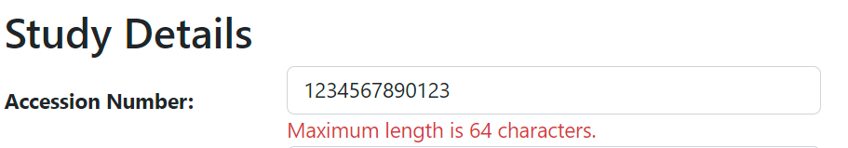

### Patient MRN length exceeds 16 characters

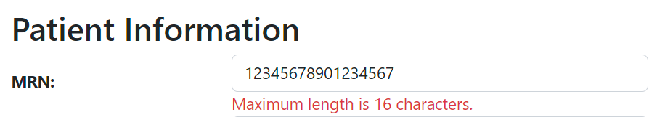

### Site Id: label showing Site Name

### Wrong MRN for Patient name creates Order with existing Patient with that MRN

Results in no error but the different patient is now created in the Orders list

Eg. Select Sarah

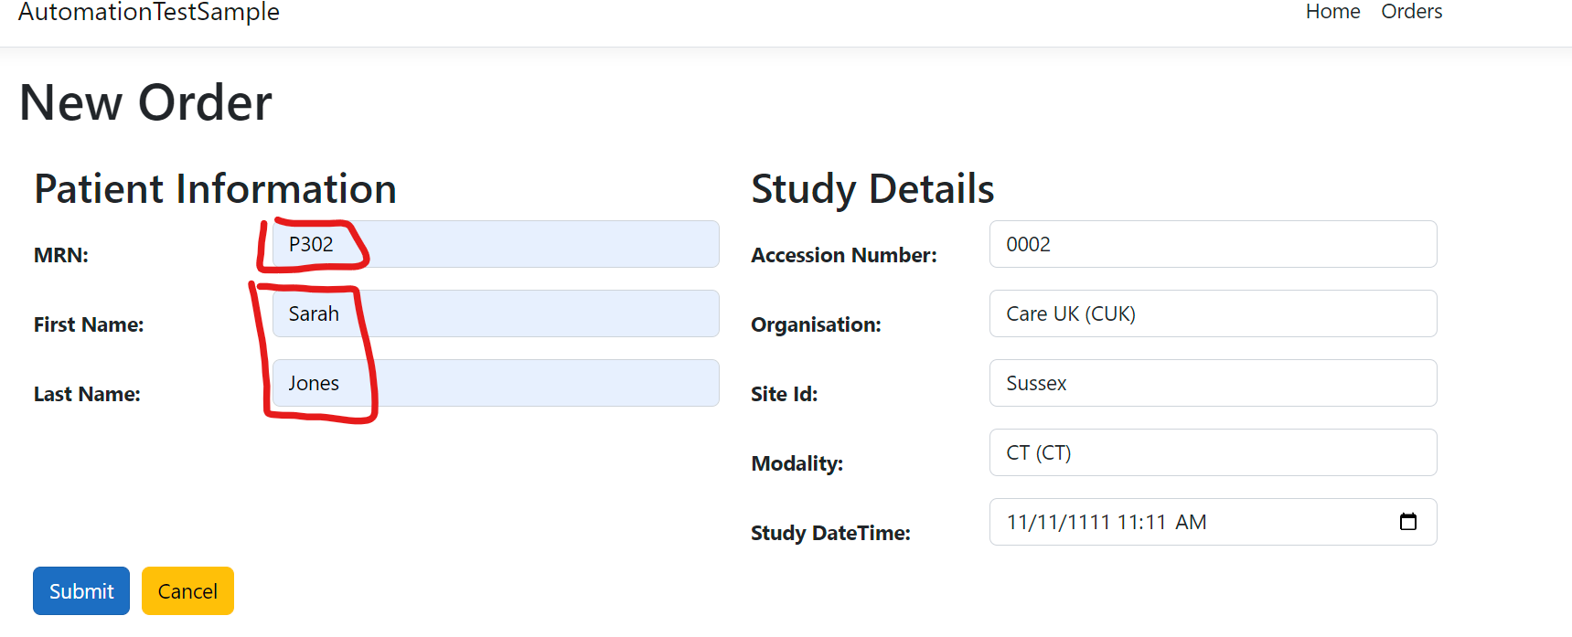

Actually created James Anderson for Accession Number 0002:



### Duplicate Accession numbers due to spaces

* Created with Accession Number – “00492 “

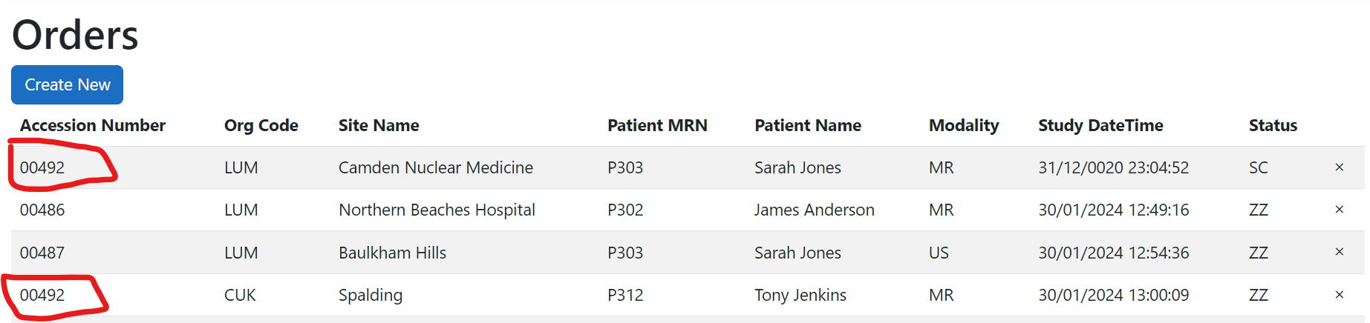

### Setting invalid Study Dates in the past

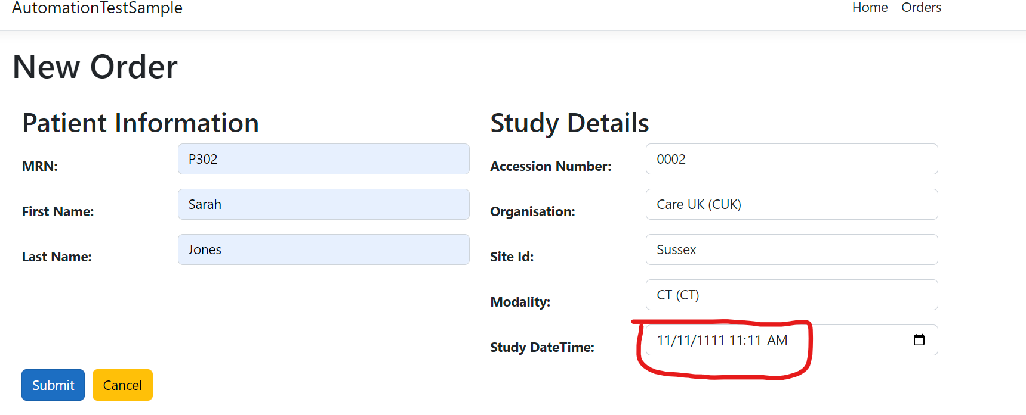

### Cancel Order option message not user friendly and states URL

